**CREATE A PARTITION AFTER INSTALLING OPERATING SYSTEM**

Open the Run Command and enter the **diskmgmt.msc**

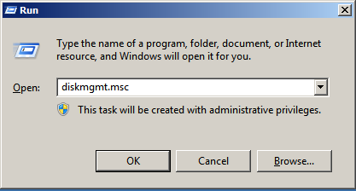

Right Click the any drive (Ex: C or D) and select the **shrink new volume** option

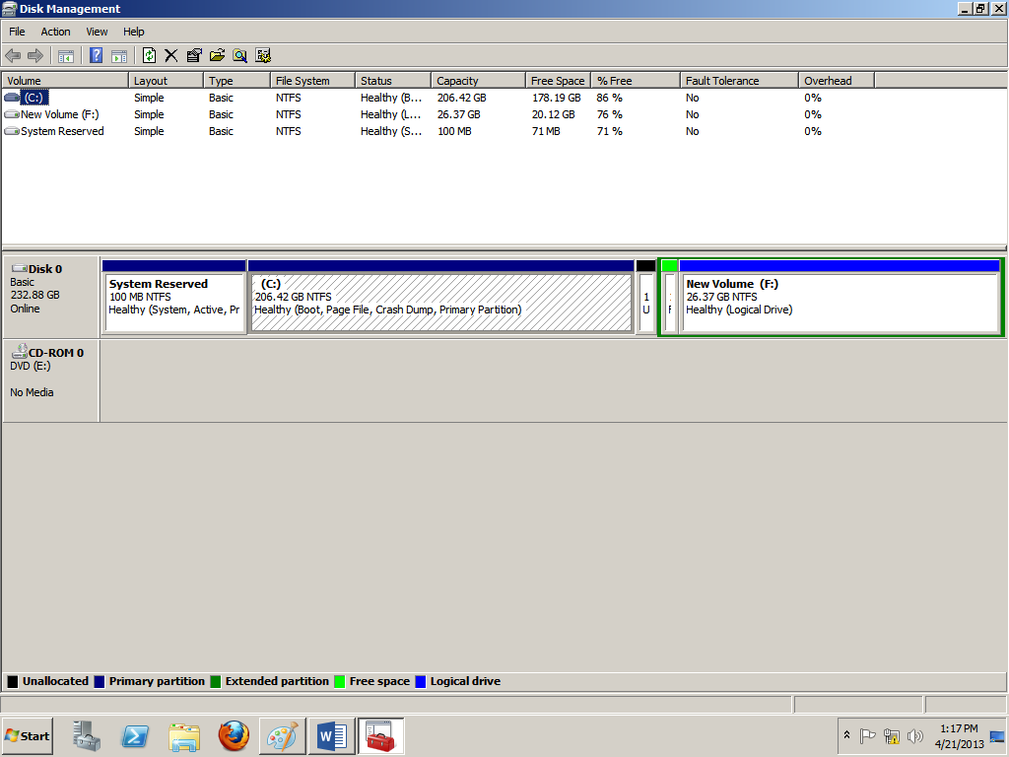

Now enter the size for creating a new partition and click shrink option

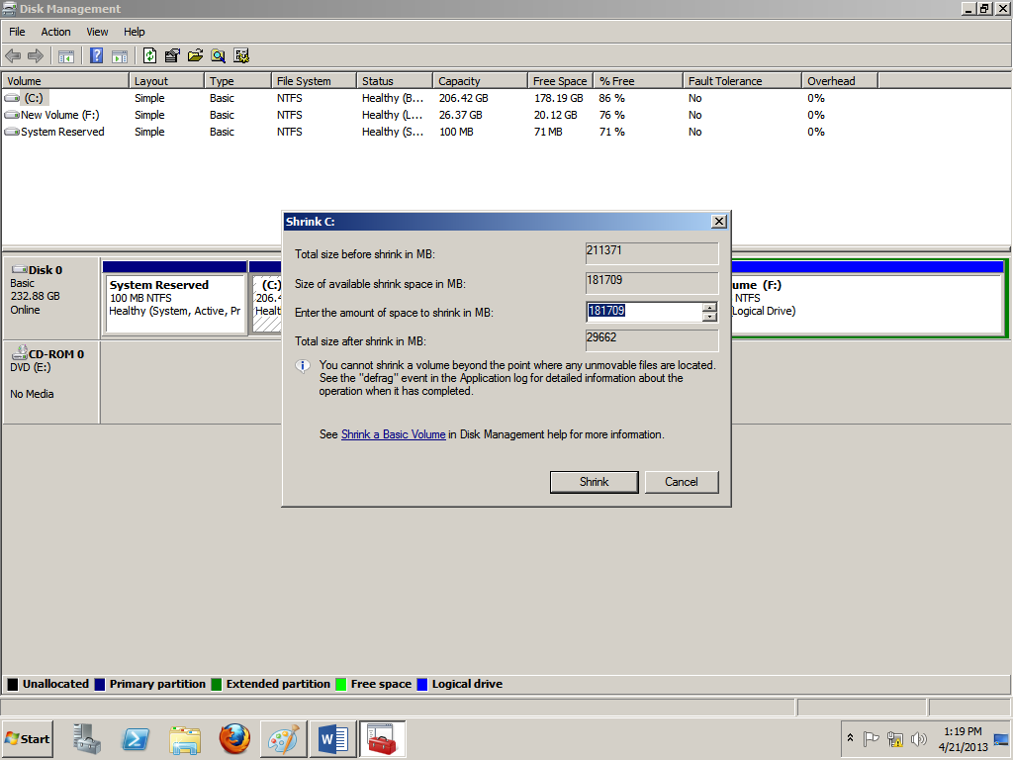

Now right click the un-allocated drive and select **new simple volume**

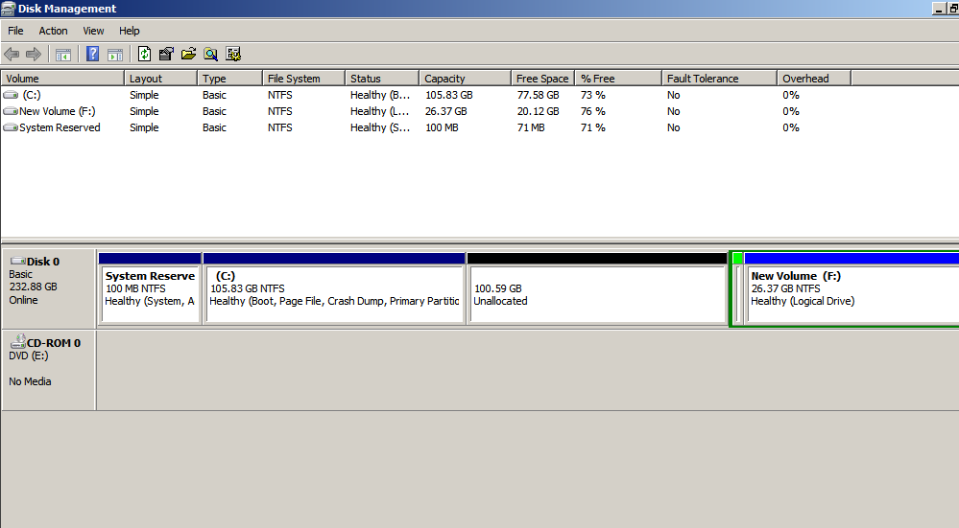

Click Next

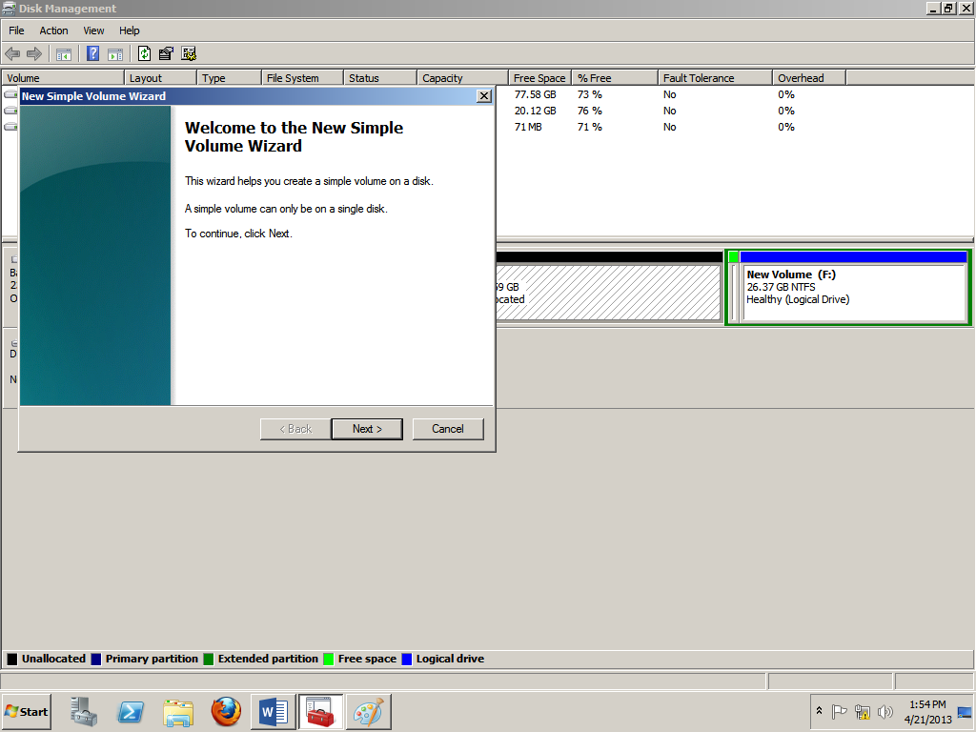

Click Next

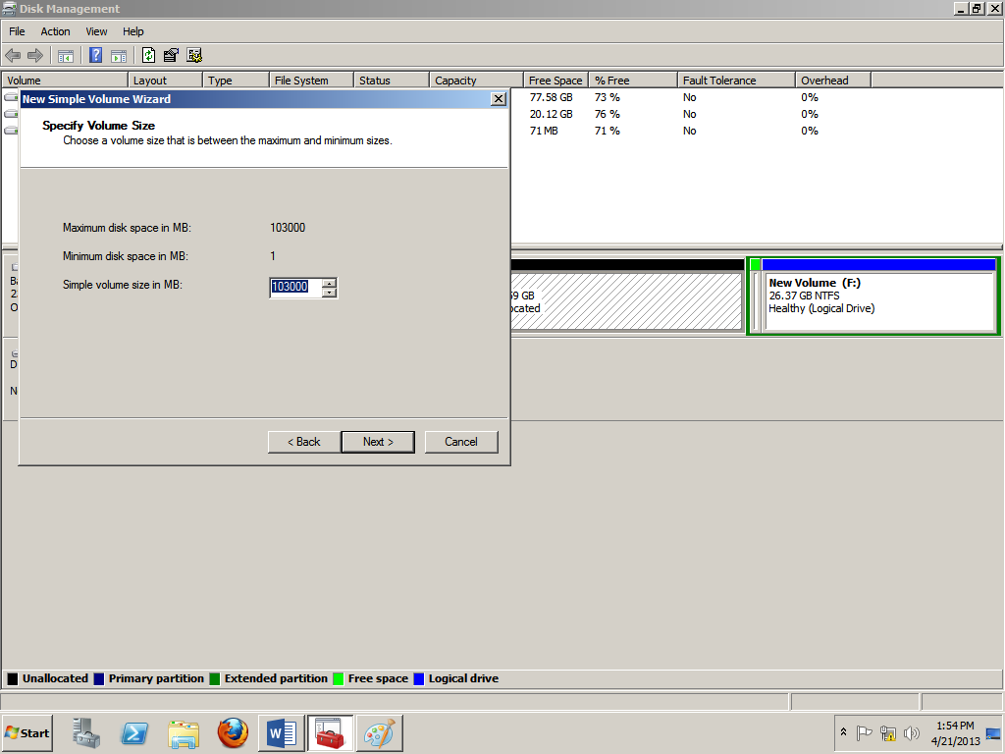

Click Next

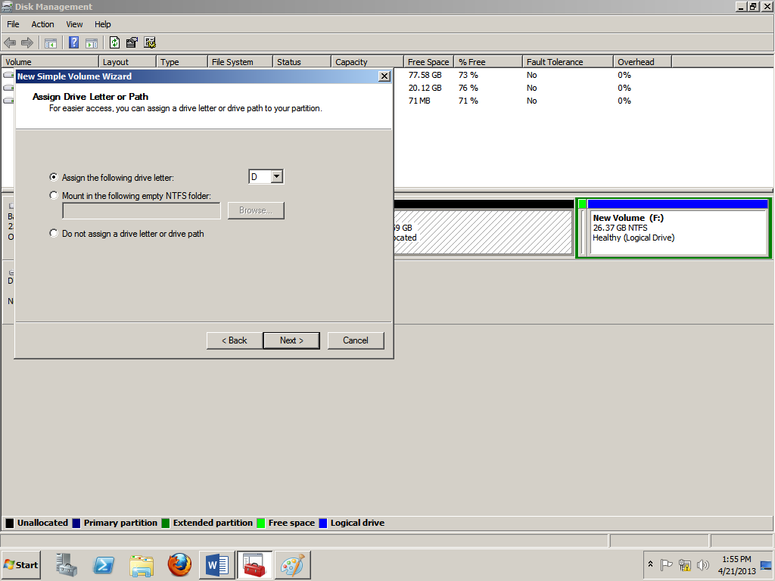

Click Next

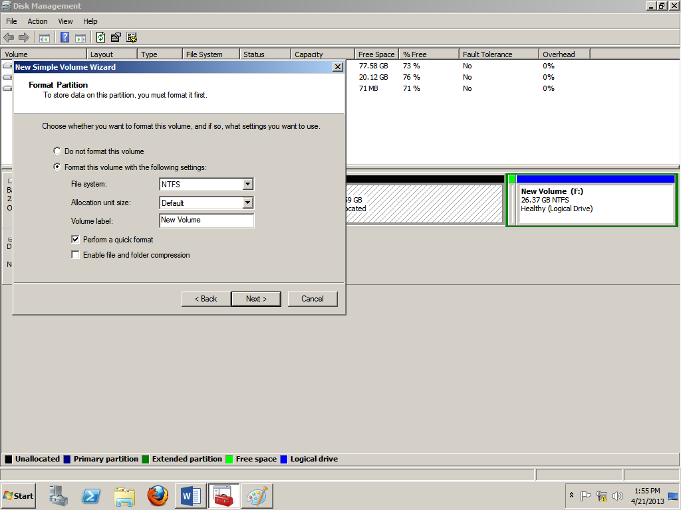

Click Finish

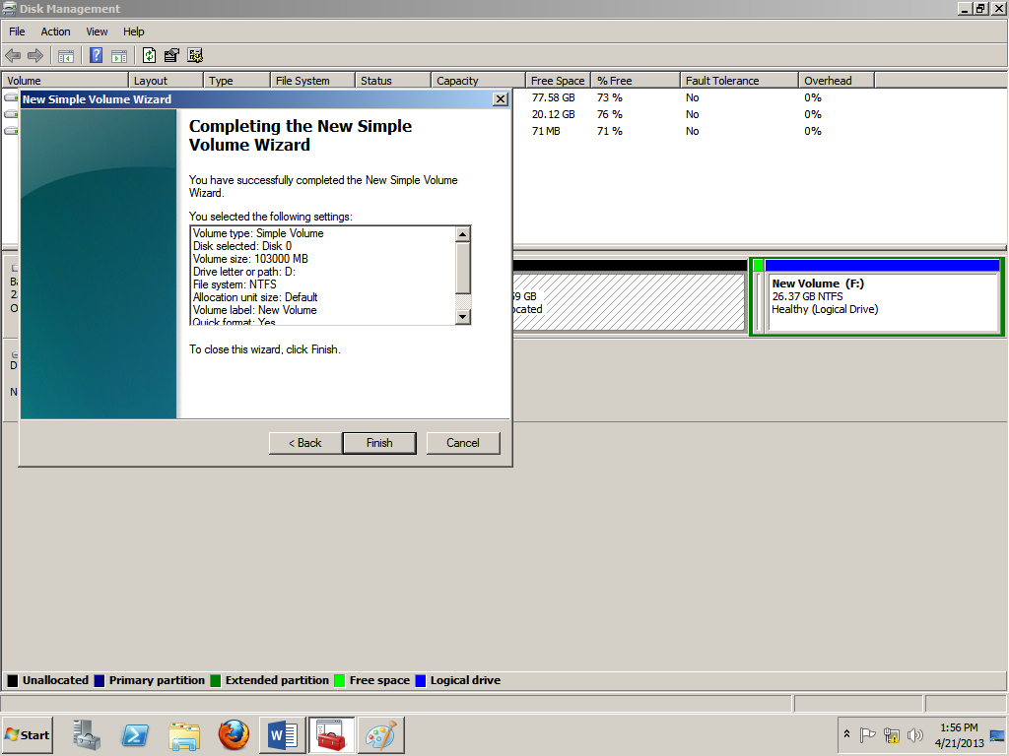

Partition Created Successfully

